Health and Safety Risk Assessment
It’s a legal requirement for you to conduct a health and safety risk assessment: -
- before you start operating a business in any premises
- where there are changes of use in any area of the building
- if there is an expected significant increase in people on site at any one time
- there are any management changes

The risk assessment is usually broken down into five elements: -
1 | Identify who is at risk
Most risk assessments have this as step number two, instead identifying the hazards first. However, when you consider that different people interact with your business in different ways, the best way to conduct an in-depth risk assessment is to put yourself in the shoes of your staff; your customers; your supply chain and then walk the walk that these people take as this will ensure your step 2 is rigorous.
Ideally you will break this down further depending on the demographics of each type of person. For example, could young or elderly people be more at risk? What about people with disabilities or those who are pregnant? Or people who don’t speak English?

2 | Identify the hazards
We suggest you break this down per group of people, identified in step 1.
For example, customers will most often arrive from through the front entrance, and you can trace their steps as they make their way to front reception or the bar or their table or a ticket booth. Where will they go from here? And from here? Can you trace an average customers step throughout their stay and at each point assess any hazards they might encounter? This could be steps; low beams; unstable furniture; burns from fires.
Your staff however might enter from a different place, and they will have access to the kitchens; laundry areas; broom cupboards and stock rooms; hazardous materials; cellars. These areas will have their own sets of hazards and again each staff member will have their own journey through your premises. Trace these steps and list all the potential hazards. This could be slips, burns, hurting backs from heavy lifting, items falling on them.
Even consider the tasks your team must complete. Do any administration staff have to spend excessive time in front of computers; can anyone get repetitive strain injury from repetition of tasks?
Your supply partners may have a different journey again. Is there a separate loading bay they use? Do they have to negotiate large boxes of food through your restaurant or café into the kitchen?
3 | Evaluate the likelihood and severity of the risk
It’s fair to say that not all risks are equal. Some hazards are highly unlikely to happen and even where they do the severity of the impact is low. However, it is important to capture every potential incident – if nothing else to protect you from any claims in the unlikely event there is an accident.

It is also important to recognise the level of severity and likelihood for all risks because the more likely and more serious the potential accident the higher the risk and the more you need to do to prevent it from happening.
We do this by grading every hazard identified from 1 – 5, where 1 is low and 5 is high and we decide the severity by multiplying the severity by the likelihood.
The chart below gives a good visual indication of what this looks like and will enable you to grade each hazard identified.

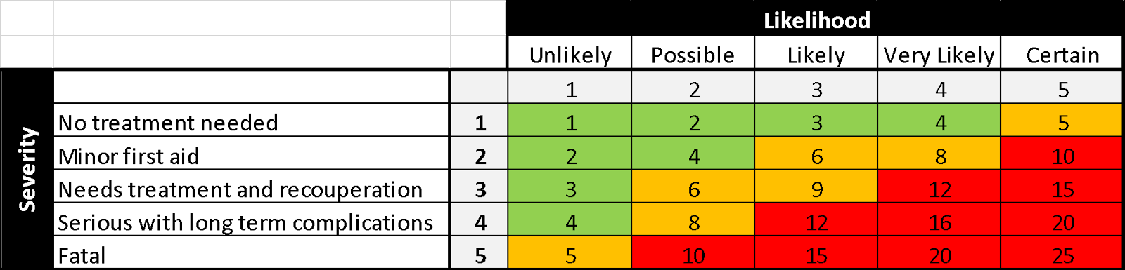

Whilst your aim should be to mitigate all risk, as a rule of thumb, anything in the green boxes (i.e., 1-4) fall into the maintain and monitor category. This might be someone slipping on the floor if they’ve come in from the rain. It’s very likely to happen but is likely just to cause a bump or graze.
Anything in the orange (i.e. 5-9) need your attention to reduce or at least put controls in place to manage the risk. Someone working in a storeroom, who is continuously lifting heavy boxes from above head height, is likely to strain their back and it is likely to need some time off to recuperate.

The red boxes (anything over 10) need urgent action and you must ensure that you have measures in place to help prevent these incidents. If you have an amusement park or anything related to water or animals, there is a likely chance that someone might become injured. Any that contain these activities brings the risk of fatalities.
And so, the next step is to look at what you are doing now and try and reduce the risk level for your business.

4 | Assess how you can eliminate or minimise the risk
In an ideal world we would eliminate all risks, but sometimes the cost and inconvenience of doing this just doesn’t make sense.
You do though need to be able to demonstrate that you have assessed whether something is reasonably practicable or not. For example, installing handrails either side of outside concrete steps that are slippery in the winter would be seen as reasonably practical given the likelihood of someone slipping and quite seriously hurting themselves. But removing low beams which would alter the architecture of a building on the off chance someone walked into the beam and received a relatively low harm bump to the head would not be seen to be reasonably practicable.
So how do you approach the task of reducing the risk you have identified?
There are 5 different approaches and the approach or approaches you take will depend on the ‘reasonably practicable’ definition in context to your hazard.
Using the slippery steps as an example, are you able to….

- Eliminate
Perhaps by using a different entrance?
- Substitute
Can you replace the steps with a ramp made from non-slip material?
- Engineer (adapt what is already there)
Could you install handrails and also non-slip concrete treads?
- Administrate (signage, training manuals, communication)
Can you put signage up warning guests about slippery steps, asking them to take care?
- PPE (protective clothing/equipment)
Provide protective clothing and shoes for guests
You can see from the above that some suggestions are ridiculous and just not feasible, but there are potentially two reasonably practicable suggestions in 3 and 4 that would substantially reduce the risk, and which would not be seen as too unreasonable in terms of cost or inconvenience.

5 | Record your findings and decide who will action this and by what date
Once you have assessed the risks involved, identified those who could be affected, rated the severity and likelihood of the risk and decided how you can either mitigate or minimise the risk, it is important to ensure your assessment is carried through. And that this is reviewed on a regular basis and against any logs in your accident book.
We have included a simple risk assessment template that will enable you to record and review your findings, demonstrate the steps you are taking to ensure the health and safety of your customers, staff, contractors and general public and it will help to inform your Health and Safety policy.

