LinkedIn Check List

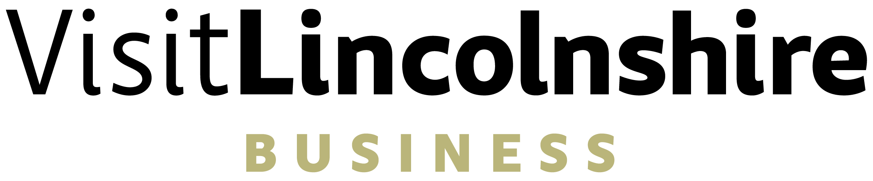
To ensure you maximise your presence on LinkedIn, you’ll need to ensure you’ve covered all bases. We’ve gone through these in detail in our video Masterclass and on our Fact Sheet – but use the check list below to see whether you need to go back and update your LinkedIn profile.
Action | Check
Ensure the name you use on LinkedIn is the name you use every day (if you are known by everyone as Tash then having your name displayed as Natasha may confuse people)
Ensure your profile picture only features you and that you look approachable, friendly, and professional

Have you customised your background to reflect your industry, business, skillset, or passion?
Does your headline demonstrate the unique value you offer?
Ensure that you have filled in your location so that you can be found in location searches.
Can people easily contact you? Whilst many will be happy to connect over LinkedIn, including an email and a website address will make it easier for people to reach out to you.
Have you created an ‘about section’ that really gives the reader a glimpse of what you’re about and that is written in a way they make them want to know more and be part of your journey? In other words be conversational. Have you created an ‘about section’ that really gives the reader a glimpse of what you’re about and that is written in a way they make them want to know more and be part of your journey? In other words be conversational .
Have you completed your education section? Remember to include courses that may not have been taken in college or university.
Have you completed your experience section and does this show your achievement rather than just your responsibilities?
Have you registered your relevant skills and asked people to endorse you for those that are most critical for the service you provide?
Do you have recommendations from past customers, colleagues, or employers? If not – ask 3 people straight away.
Have you added materials to your story that backs up what you say you do? Presentations, certificates, awards, photos etc.
Have you checked out and signed up to any relevant LinkedIn groups? This shows you like to be part of a community.
Are you following relevant organisations and businesses that are of interest to you personally and professionally? This shows you are not one dimensional.
Have you developed a content plan that is achievable for you and relevant for your audience?
When you ask to connect with people do you include a personal and tailored message with your connection request?
When people ask to connect with you, do you have a tailored message thanking them for engaging with you?
Do you allocate some time each day checking through your feed so that you can remain engaged?

