
What makes you stand out from the crowd

The template below gives you a guide to how to assess every touch point of your service from booking to post experience communication. Feel free to amend the touchpoints to match your specific business – adding in lines where you need to.

Touchpoint | How you deliver it | What is the benefit
Provide information
Take bookings
Confirm bookings
Take payments
Entrance
Welcome guests/arrival
Guest room
Bathroom
Dining room/restaurant
Bar area
Bar selection
Menu selection
Outside space
On-site activities
Nearby activities
Transfers
Babysitting

When completing a positioning map, it's very tempting to place yourself where you want to be positioned (let’s face it most of us would like to be in map A rather than map B), but it's vitally important to be as honest as possible because that’s what your customers will be.

[A] [B]
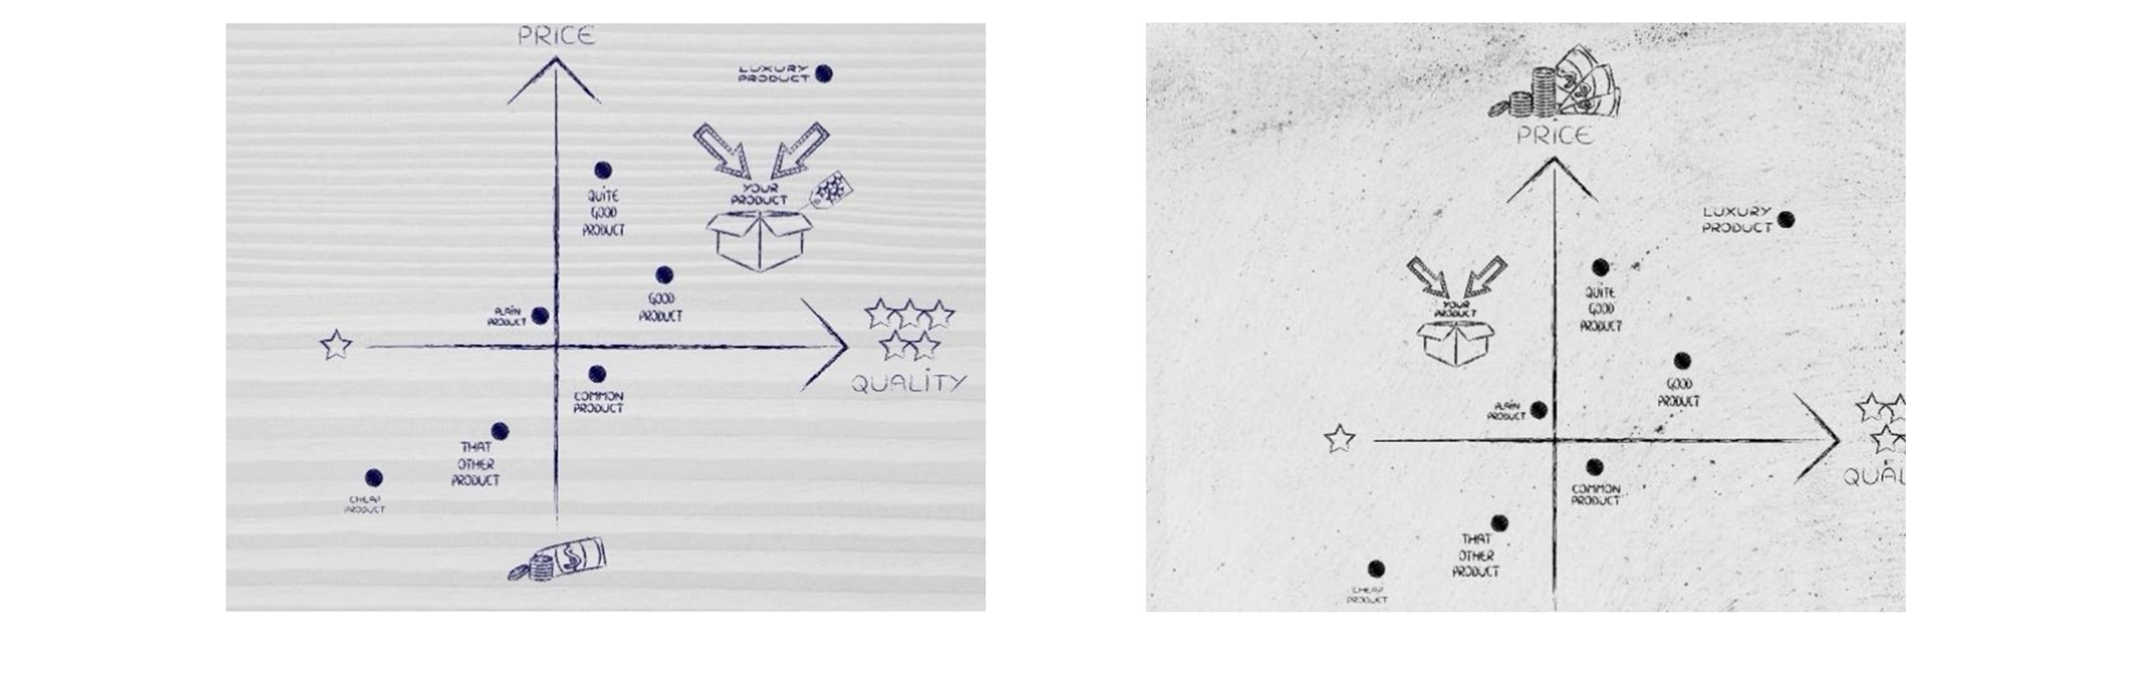

- How can you make sure you are being objective?
Ask, ask, ask, ask, ask, ask. Use feedback cards in rooms, look at on-line reviews, ask open questions over breakfast and/or when guests check out and use the feedback to help you create a leading market position for your business and your ideal customer.
And once you’ve identified your points of difference, tailor all of your marketing efforts to communicating this and the benefits they provide.
Brand positioning template
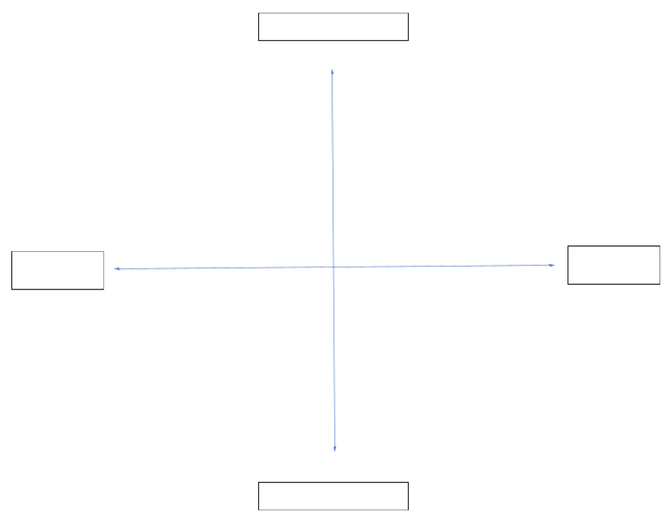
Once you’ve done this can you identify what everyone else who offers a similar product or service provides for their customers? There are templates available on this site that will help you capture information on your competition. To find where there might be gaps in the market and to really see where your point of difference is, it’s often helpful to also plot businesses on a brand positioning chart. We have included this on the last page for you to adapt for your business.
Once you have plotted where other providers of the same service sit on the chart, where do you sit? What type of customers will be attracted to this quadrant? Is it the customer segment you want to serve? If not, what do you need to do to move across into the quadrant and position you want to be in?
Depending on your business and the customer segment you serve, you will amend the categorisation accordingly but to give you some examples your categories might be.
Business Type | Axis 1 (vertical) | Axis 2 (horizontal)
Bed & Breakfast | High price / Low price | High quality / low quality
Hotel | Out of town / central location | Basic facilities / Full facilities
Café | Healthy Food / Junk Food | Limited choice / Wide choice
Restaurant | Basic décor / luxury decor | Self Service / Silver Service
Holiday Park | Walk to beach /drive to beach | Basic facilities / Full facilities

You will need to define these further based on what is important to you – for example you may decide that basic facilities in a hotel are having a reception desk and guest bedrooms; full facilities would include a restaurant, bar, gym, pool and spa.

